Shabbos Stories for
Rosh hashanah 5783
Volume 14, Issue 1 – 1-2 Tishrei 5783/September 26-27, 2022
Printed L’illuy nishmas Nechama bas R’ Noach, a”h

For a free subscription, please forward your request to keren18@juno.com
Past stories can be found on the website ShabbosStories.com
The Shofar's Stirring
Message for Today
By Rabbi Benjamin Blech

Tragedy has its powerful language which transcends words and alerts us to the kind of pain experienced by so many during the global pandemic.

There was a young man in my community who, because of a terrible accident, went into a coma that resisted medical intervention. For months he responded to nothing in his surroundings.
On Rosh Hashanah the hospital chaplain, making the rounds to extend the opportunity to fulfill the mitzvah of hearing the shofar, almost passed him by. What would be the point, he initially thought to himself. The doctors told the rabbi that the patient “isn’t really here.”

Perhaps the Shofar Might Reach His Soul
But upon reflection, the rabbi decided that even if the man’s mind was incapable of responding to G-d's mystical notes, perhaps the shofar might reach his soul. After all, the soul was brought into existence by G-d blowing into the physical form of Adam "the breath of life," investing in him some of His divine spirit. It is the soul which defines us as sharing “the image of G-d.”
Immediately after the sounds of the shofar the young man’s eyelids began to flutter. His lips started to move. He recognized those around him.
How was that possible? The answer is both simple and profound. The wavelength on which the shofar operates is on a different level than the one that communicates with the ears and the mind. Our neshamah, our soul, hears what we do not hear – or what we do not choose to hear. Our soul is more attuned to reality than all of our other organs. Our soul is who we really are – because it is the closest link we have to our Creator.
It is no accident that when we speak of someone who died we say he expired. The word expired comes from the Latin “ex” and “spiritus.” “Spiritus” means breath; “ex” refers to its leaving. Death is the moment when the original breath of G-d returns to its source. It is the disappearance of G-d’s presence which we refer to as dying. It is acknowledgment of G-d’s continued sharing of our existence that is the true meaning of living.
After silence, that which comes nearest to expressing the inexpressible is music.
Whenever we acknowledge that truth we are “inspired” – “in” “spiritus” – filled with the awareness of the divine breath which defines our partnership with G-d.

A Level of Divine Communication
The mitzvah of shofar shows us that there is a level of divine communication that transcends the rational. It demonstrates that a mitzvah can accomplish its goal in a moment, that the emotion of a musical note can mean more than a brilliantly expounded message.
Perhaps Aldous Huxley said it best: “After silence, that which comes nearest to expressing the inexpressible is music.”

The Three Sounds of the Shofar
The rabbis of the Talmud revealed the meaning of the musical messages. Yes, they need to be felt. But they also need to be understood because they convey some of the deepest truths of our lives’ experiences.
Each of the three sounds of the shofar has a role in preparing the mind and soul of the listeners to the spiritual process they are about to go through – and the theological meaning of our ongoing encounters with G-d.
The first sound is the tekiah. Its long, uninterrupted and straight blast is stability. It is discipline and consistency. It was used as the sound of the coronation of the King. It is a note of joy and of hope, of belief in the ultimate goodness of the universe and its inhabitants. On Rosh Hashanah G-d is crowned as King of the universe. The tekiah was blown to call the people together for joyous occasions and the sharing of good news.
If only our lives would always be filled with “the sound of music” that encourages us to sing and to dance, to celebrate and to rejoice. But we also need to acknowledge that life invariably also brings in its wake moments of pain, sadness and desolation. These moments are expressed by shevarim and by teruah, the two other sounds of the shofar.

Tragedy Has its Powerful Language which Transcends Words
Shevarim means broken. They are the sounds of sickness, the musical sighs of what Yiddish so aptly calls a krechtz. Oy, oy, oy! Tragedy has its powerful language which transcends words and alerts us to the kind of pain experienced by so many in these past two years of global pandemic. This broken threefold expression is followed by the nine gasps of the broken teruah, emphasizing the test of faith we've had to endure as we witnessed the horrors of sickness and death exceeding anything we ever could have imagined.
After expressing our recent travails, we maintain our hope in the final blast of the shofar that signals an end to the cycle of tragedy, ushering in the long-awaited era of universal peace and joy.
After the wail of the shevarim and the staccato blasts of the teruah, giving expression to our recent travails, we still maintain our hope in the final tekiah gedolah – the long straight blast of the shofar that will not only bring an end to the cycle of tragedy but will usher in the long-awaited era of universal peace, tranquility and joy.
That is the shofar's musical message that seeks to speak to our souls. I can’t help but believe that the young man who was brought back to life from his nearly fatal coma by the sounds of the shofar managed somehow to hear far more than the music. His soul heard the message.
My prayer for this for Rosh Hashanah is that we all grasp the message of the shofar as well – and that our lives finally pass beyond the notes that bespeak tragedy so that we may at long last be blessed with the tekiah gedolah, the final great blast of divinely promised redemption.

Reprinted from the August 28, 2021 website posting on Aish.com

A Most Special Shofar

Rav Dovid Hoffman writes that every year on Rosh Hashanah, hundreds of Jews in the Old City of Yerushalayim would flock to the Shul of Rav Yoel Chaim Weissfinger, zt"l, for the unique experience of hearing him blow the Shofar. When Rav Yoel Chaim passed away a few days after Yom Kippur in 1913, he left behind two sons, Shimon and Leibel. It wasn’t clear which one would inherit their father’s prized Shofar, and along with it, the honor of blowing it in Shul, and in the end, Leibel, the younger brother, who was a respected Torah scholar, inherited the Shofar, while Shimon, the eldest son, inherited the small grocery store his father had owned.
Shimon eventually sold the store, moved to America and became a wealthy man. A few years later, war broke out between the English and the Ottoman Turks in the Holy Land. Unfortunately, Leibel was arrested by Turkish soldiers, thrown into jail, and deported to Egypt.

Set Sail to Egypt to Save His Brother
When Shimon learned what had happened to his brother, he immediately set sail for Egypt, located him, and had him freed. He then gave Shimon a large sum of money, which enabled him to return home and get back on his feet. On the day Shimon was to return to America, Leibel was overcome by emotion, and he presented his older brother with their father’s Shofar as a token of his gratitude.
Shimon was very touched, and the whole way home he guarded the treasured object, and never let it out of his sight. But when he went to show it to his friends and family, he almost fainted. It was missing! The ancient Shofar had somehow disappeared.
Years passed, and due to financial constraints, Leibel and his family emigrated to Poland, where he found a position as a Rav in a small village. Perhaps, he hoped and prayed, that his worries were over. However, it was not to be, as the Second World War soon erupted. Over the next few years Leibel endured the tortures of the Holocaust, and miraculously survived.
When the War ended, he spent several years wandering from one D.P. camp to the next, hoping to eventually return to Israel. One Erev Rosh Hashanah, the group of Jewish refugees with whom he was traveling found themselves at the home of a kindly Italian farmer who agreed to let the group stay over Yom Tov.

The Old Italian Farmer’s Story
The refugees were saddened by the fact that they had no Shofar, but then something unusual happened, and the old Italian farmer said that he had something important to tell them. He said, “Many years ago I was a crew member on a ship that sailed from Palestine to America. One of the passengers was a wealthy American Jew, who held on to a small package the whole time as if guarding a great treasure. When the ship docked in America it was a tumultuous scene, and I’m ashamed to say this, but I took advantage of the opportunity and I stole the package from him. I was very disappointed when I opened it up because all it contained was this strange looking thing,” and the farmer then withdrew a very old shofar from its case.
“I know that this is some kind of Jewish object, and for years I’ve been hoping to meet some Jews so I could give it back. Please take it. It will obviously have some meaning to you.”
Leibel Weissfinger paled. Indeed, what he was looking at was none other than his father’s Shofar! Leibel eventually reunited with his brother Shimon and together they cried tears of joy as they shared the long-lost Shofar, and pondered the mysterious ways of Divine Providence!

Reprinted from the Rosh Hashanah 5782 email of Rabbi Yehuda Winzelberg’s Torah U’Tefilah.

The Forbidden Shofar Blast

Rav Gamliel Rabbinowitz, Shlit”a relates, “I heard a story about the Munkatcher Rebbe (Rabbi Chaim Elazar Spira), whose grandson asked him every day in the month of Elul to blow the Shofar for him, and so, every day in Elul, he took out the Shofar and blew for him.
On Erev Rosh Hashanah, the grandson again asked to hear the Shofar as he had every day for the last month, however, we do not blow the Shofar on Erev Rosh Hashanah, for several reasons. But the grandson did not want to hear that we do not blow the Shofar on that day, and he burst into tears, which tore at the heart of his grandfather, as he urged him to blow the Shofar for him.
The Munkatcher Rebbe could not take the crying of his grandson, and since he had no other way to silence the cries of the child, he said that he would blow just one blast, and no more, just to stop his crying, and that is what he did.

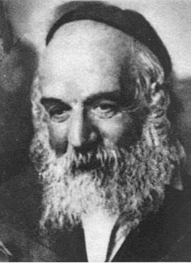

On Rosh Hashanah, before Shofar blowing, the Munkatcher Rebbe stood to give his arousing Drashah before the blowing, and he said, “I sinned a great sin before Rosh Hashanah,” and he told the congregation about what he did, because he could not take the crying of his grandchild who wanted to hear the Shofar.
And then the Tzadik started crying himself. He lifted his eyes to Shamayim and made his request, “Ribono Shel Olam! Please, also hear the sound of our crying, and may You blow one blast of the Shofar for us, as we say in the weekday Shemoneh Esrei, ‘Sound the great Shofar for our freedom!’ Please redeem us already, your Nation of Klal Yisroel, from this long exile!”
Rav Gamliel continued and said, “Immediately after I heard this story, a young man came to see me. He was brokenhearted from the pain and distress that his wife was causing him, to the point that he decided to leave her, since he could no longer bear being with her.
I told him the story of the Munkatcher Rebbe, and I told him that if he goes back home, I promised him that it would be a great salvation for Klal Yisroel. I told him, “If you control your emotions, Hashem will have mercy on His people!”
He immediately accepted this, and he went back home, of course, with direction and encouragement on how to continue, and today, Baruch Hashem, they are living in harmony and peace!”

Reprinted from the Rosh Hashanah 5782 email of Rabbi Yehuda Winzelberg’s Torah U’Tefilah.
Where We Stand
By Larry Gordon

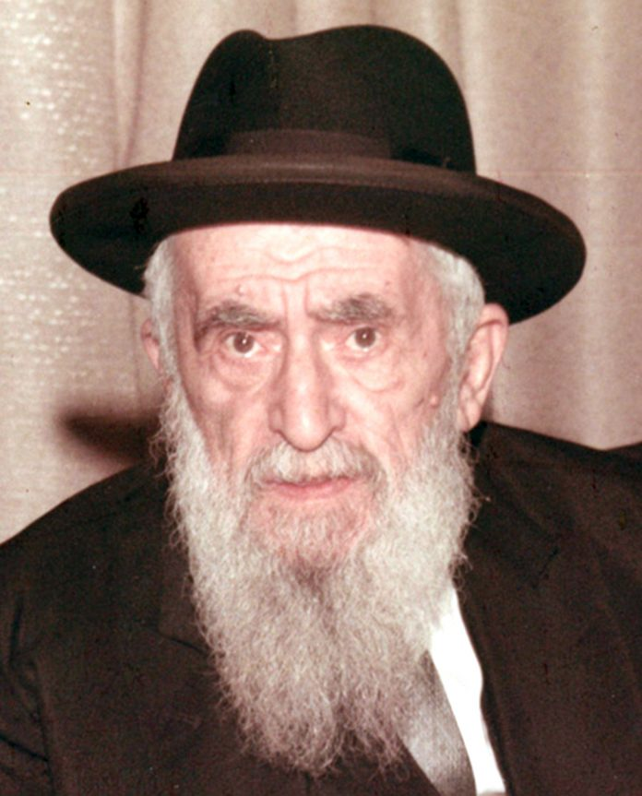
Rav Moshe Dov Ber Rivkin

The seating charts are out and are already posted on the wall in many shuls. So as we enter the New Year, and review the year that was, we may not know exactly where we stand, but with a cursory look at the chart, at least we know where we sit.
Yes, it’s the time of year to take stock, do a cheshbon ha’nefesh, an inventory of our thought processes and priorities. And perhaps on the surface, where the seating committee evaluates where we belong in shul probably helps us along in figuring out not just who we want to be but who we are.

Those Days We Genuinely Thought They Would Never End
I think I’m in the post-seating-chart part of life, but of course you never know what the future will be. The first quarter-century of my life I davened on yom tov at the main international Chabad shul at 770 Eastern Parkway in Brooklyn. Those were indeed the days, my friend; we genuinely thought they would never end.
There were no seating charts in 770—at least none that I knew of. Somehow people knew where they belonged. I don’t know if that is really so anymore.
The Rosh Hashanah and Yom Kippur minyan at Chabad in Crown Heights at which my father and his children davened for many years was not your average minyan. It dated back to the 1940s when the Frierdiker Rebbe, R’ Yosef Yitzchok Schneerson, was immobile, in a wheelchair, and required that a minyan be organized on the same floor where he and his wife resided on the third floor of World Lubavitch headquarters.
I’ve written about those years more than a few times, so I beg your indulgence if I’m repeating this unique history that is still so vivid to me. I am still studying those years, conjuring different aspects of the experience from year to year.

A Majestic Experience Shrouded in Simplicity
Thinking back, it was a majestic experience, but also shrouded in simplicity. For example, how did one go about securing a seat at this minyan, which took place in the Rebbe’s library up on that third floor?
As teenagers it was our job annually to make it to shul early on erev Rosh Hashanah to survey what was going on in that room. Many years later I asked a caretaker at 770 to take me up there again to look around and I was struck by how small that room really was. Our job was to walk down the long hallway to what was the home of the previous Rebbe and slide the dining-room chairs from around the dining-room table down that hall and into the library where the minyan was held. The mission was just to secure the several chairs that we needed.
There were three types of seats one could have at this minyan. The first and most preferable were the regal dining-room chairs that had a shiny brown leather-like look. The second choice was a folding chair that had red cushion-like material on the seat and the back. The third option that was in place before anyone arrived was the plain wooden benches that were placed around the circumference of the room.

Leather Chairs Were for the Exclusive Use of the Adults
Children did not have the right to the leather chairs; those were for the exclusive use of the adults. In our case, however, since our father was the ba’al tefillah, we were able to take turns sitting on his chair while he was at the amud.
This week’s Torah reading is Nitzavim, which means “standing.” The first pasuk quotes Moshe addressing the Jewish people, saying, “Today you are standing, all of you together, before G-d, your G-d, the heads of your tribes, your elders, your police officers, every Jewish person.” The next pasuk goes through the different people standing before Hashem: “Your young children, women, and converts within your camp, your woodcutters and water-drawers…”
Right there in the first two sentences of the parashah there is a reference to how we are all standing together, united as one, but then it goes on to depict the different types and levels of people who are supposed to be included in this united group. Are we truly one people, or are we a disparate collection of various groups of people at different stations in life?
One of the answers is that by virtue of our G-dly souls we are indeed united as one people at this time of year, “all standing together”—in judgment, perhaps—before Hashem.

The Upstairs Minyan
Back in 770 at what we used to refer to as our “upstairs minyan,” we did not do a lot of standing up, as the relatively small room did not have an aron kodesh where the Torah scrolls could be stored. So, over all those years there was no opening and closing the aron as instructed somewhat frequently in our Machzorim.
When it came to the Torah-reading part of the service, two men from the minyan went to one of the downstairs minyanim to borrow two sifrei Torah and bring them up to our room where my father was also the ba’al korei. The point is that during the davening on both Rosh Hashanah and Yom Kippur when it states that this is where the aron is opened, we didn’t have one, so we just didn’t open it up or stand.
As we head into 5882, there is one more thing that I have to recall, and that is the personage of Rav Moshe Dov Ber Rivkin who served as the de facto rav of this minyan. Rabbi Rivkin blew the shofar for many years and was given the maftir aliyah on both days of Rosh Hashanah. Rabbi Rivkin was a Lubavitcher chassid and also a rosh yeshiva in Yeshiva Torah Vodaas. Two things about him caught my attention, and all these years later those recollections have never left me.

Rabbi Rivkin Sobbed Uncontrollably
The first was the way he read the haftarah that we read on Rosh Hashanah about Chana, her deep and sincere prayer for children, and how she was criticized, so to speak, by Eli HaKohen during this period of the Mishkan in Shiloh. The story of Chana and her inability to have children is always heart-wrenching. But Rabbi Rivkin sobbed uncontrollably as he recounted the fashion in which Chana beseeched the Ribbono shel Olam until she was successful and did in fact give birth to a son who grew up to be Shmuel HaNavi.
From observing the rabbi I learned to internalize that story year after year and later learned that the way in which Chana davened was the barometer of how a Jew can and should daven, particularly at this time of year. I think that what we need to know is that our tefillos can have impact and change things from a personal as well as a communal perspective.
Rabbi Rivkin, who always looked like an elderly man to me, also blew the shofar in our upstairs minyan. He blew slowly, methodically, and with strength. But there came a time, in 1973 or 1974, when he tried to blow into the black shofar that he used year after year but it just would not make a sound.
I recall watching as he finally gave in and handed his shofar over to a younger man who was a regular at our minyan. That person blew the shofar in the years that followed.
As I’ve recounted in previous years, the best part of the davening for me was joining my father under his tallis as he led the minyan in Birkas Kohanim. This signaled the end of the service and I could see on my father’s face that he was pleased with what he had delivered. He swayed slowly as he led the kohanim in the priestly blessing. As he moved from side to side, he put his arms around my brother and me and we gently rocked with him in rhythm. I looked up at his face, watching him mouth the words with his beautiful melodic tone. Then our eyes would meet and he would smile.
We stood together, and in a sense we still stand together today. After all, that’s how this week’s parashah begins: “You are standing firmly today, all of you together…”
Shanah Tovah.

Reprinted from the September 3, 2021 edition of the Five Towns Jewish Times.

The Verdict is In!
By A. Ben-Ami
Adapted from the teachings of Rav Avigdor Miller z"l

“Boys”, said Totty. “Rosh Hashanah is coming soon and I’d like to do something to help us prepare.”
“Okay!” said Yossi. “Are we going to go buy a fish head now?”
“We also need pomegranates!” said Itzik, as they headed out the door.
“No,” said Totty. “Mommy will take care of all that when she shops for Yom Tov. This is something else.”
Totty and the boys hurried to catch the bus. The boys wondered where Totty could possibly be taking them as they got off and walked towards what looked like some government buildings in Yerushalayim.
“Boys,” said Totty as they approached the entrance to a large building. “This is a courthouse. There are criminal trials being held today and I thought before the Yom HaDin it would be a good idea for us to experience what din really means.” “Whoa!” exclaimed Yossi. “Do you mean that we might actually see someone get sentenced to jail for the rest of his life? That’s such a scary thought!” “Perhaps,” said Totty as they walked into the building and towards the courtroom. “There is no way to know until it happens. Just like Hashem’s din on Rosh Hashanah.”

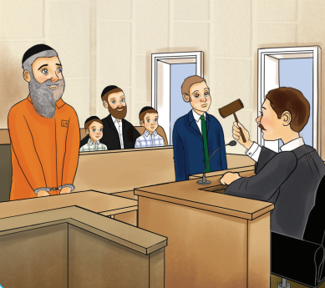
illustration by Yocheved Nadell

Quietly, Totty and the boys entered the courtroom and took their seats. To their surprise, the defendant was none other than Tzadok “HaTzadik” - the swindler who was arrested for selling phony “segulos” outside of their shul! “Tzadok,” the judge was saying. “I have reviewed all of the evidence in this case, and I have listened to your defense. Now before I pronounce the verdict, would you like to make a statement? Let me remind you that the prosecution has done a good job of demonstrating that all of the things you sold, from the ‘Har Sinai rocks’ to the ‘red kabbalah strings’ were fake. In fact, DNA evidence has proven quite conclusively that what you claimed to be hairs from Bilaam’s talking donkey were in-fact hairs from your own beard.”
Tzadok stood up. “Yes Your Honor, I would like to say something. First of all, I want you to know that Rav Volender has shown me the importance of teshuva and I have been klapping ‘Al Cheit’ so hard that I have a bruise on my chest. I plan on learning the whole Zohar so I can sell segulot that actually work and find the real hairs from Bilaam’s donkey. And if you let me go, Your Honor, I promise that I will pray for you for 40 days at the Kever Rachel that I am planning to build in Eilat.”
Tzadok finished speaking and sat down. The judge banged his gavel twice. “All rise for the verdict!” he announced.
Everyone in the courtroom stood up. Yossi and Itzik shivered in fear as they realized that Tzadok’s fate would be determined by the next words the judge would say.
Not Guilty by Reason of Insanity
“Tzadok,” began the judge. “Your statement just now has confirmed everything I heard and saw during the trial. As such, I hereby pronounce you ‘Not Guilty by reason of insanity’. Case dismissed!” The judge banged his gavel one last time. For a moment, stunned silence filled the courtroom.
Then Tzadok leapt into the air. “Thank You Hashem!” he exclaimed. He started dancing and singing “I love You, Hashem” as he bounced out of the courtroom, skipping, hopping, and turning cartwheels down the hall.
As everyone else filed out of the courtroom, Totty turned to Yossi and Itzik. “Boys,” he said. “Aside from getting a taste of what it means to be standing in front of a judge, there is another big lesson we can learn from what just happened.” “That if we’re crazy we get away with things?” asked Itzik.
“No, no,” Totty said, shaking his head. “In fact, that’s the one thing we shouldn’t learn from. But look at how happy Tzadok is, how he’s celebrating that he was given freedom. That’s how we should be right now!”
“But Totty,” said Yossi. “It’s not Rosh Hashanah yet. How could we celebrate before we actually get judged by Hashem?”

“Why Should We Be Any Less Excited?”
“Before?” asked Totty. “It’s almost one year since last Rosh Hashanah. Hashem doesn’t let us know right after Rosh Hashanah and Yom Kippur whether it was decided if we will make it until the next year. But now, looking back, we can see that Hashem did judge us for a year of life. So why should we be any less excited? It’s as if we just got a letter telling us the verdict of our case - who cares if we received it late? We need to be singing our praises to Hashem, thanking Him for giving us another wonderful year of life!”
Yossi and Itzik looked at each other and then started skipping, dancing, and singing “I love You, Hashem” with Totty as they headed towards the bus stop.

Reprinted from the Rosh Hashanah 5781 email of Junior Toras Avigdor.

